Summer Review of Algebra 2 To Be Ready For Precalculus !!! Attention!!! “Ctrl + Click” to follow links if they do not open by just clicking !!!
In the table below you will find links to documents and videos organized per topic. The column on the left has the links to the notes that will go along with the videos. Of course, the notes are not completed, since you will do that as you follow along the video, or even better yet, you should try to work out the problems in the notes on your own, then watch the video to check your work and/or review the ones you did not know how to do yourself.
Summer Review Notes to go along videos | Video Links
Basic Parent Functions & Their Characteristics | Basic Parent Functions & Their Characteristics
Basics About Functions (Evaluation Average Rate of Change Operations Composition Inverse One-to-One) | Basics About Functions: Evaluation, Average Rate of Change, Operations, Composition, Inverse & One-to-One
Laws of Exponents & Radicals | Laws of Exponents & Radicals
Various Factoring Method | Factoring
Solving Equations | Solving Equations
Rationalize Denominator & Simplify Complex Fractions | Rationalize Denominator & Simplify Complex Fractions
Once you reviewed using the resources above, you need to try completing the following packet. This is a bouquet of mathematical concepts that will be used throughout the Precalculus course. You should be proficient with most of those concepts.
Fluency comes with practice! Keep tickling those brain cells.
PreCalculus Back to School Readiness Review or Summer Packet (Joan Kessler)
Anchor yourself to a good start, spread your review sessions throughout the summer, and remember that KCHS offers a Summer Math Camp to help you be prepared! Be on the lookout for an email from Mrs. Parris this summer with more information about the Math Camp.

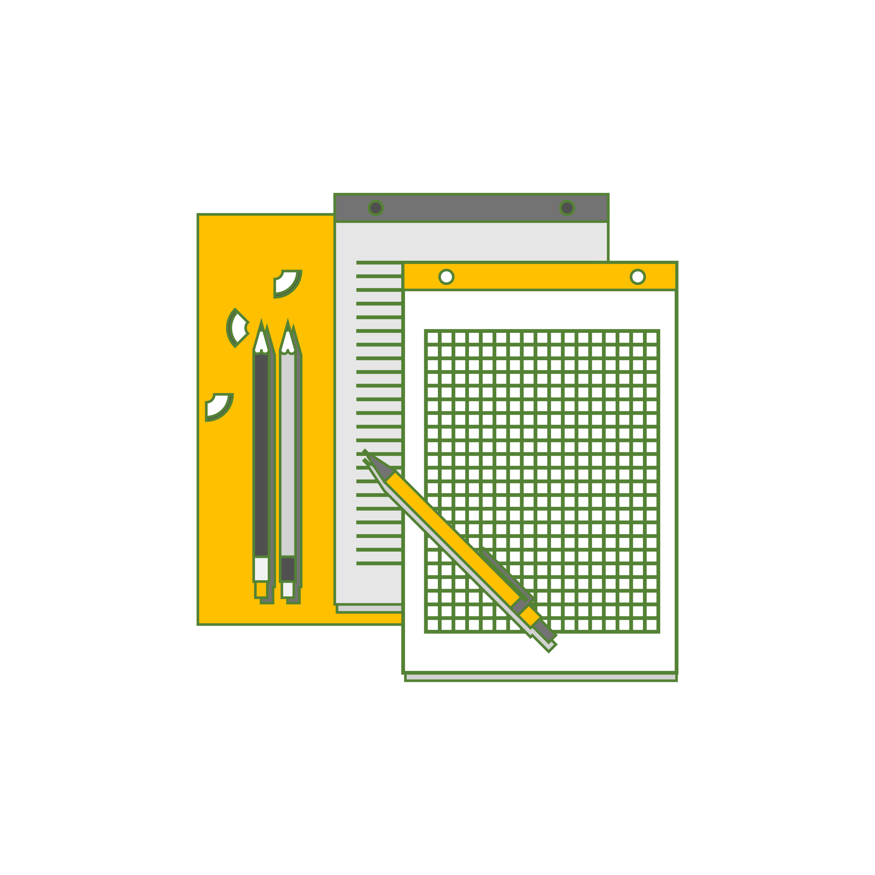
!!! Expectation !!! You will be held responsible for understanding those prerequisite concepts with a preassessment test that will be given the first week of school.

