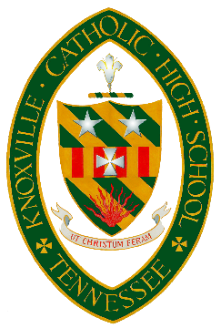
2024-2025
TUITION FINANCIAL AID GUIDELINES
(NON-CATHOLIC FAMILIES)

TUITION SUPPORT MUST BE APPLIED FOR THROUGH THE FACTS GRANT AND AID ONLINE APPLICATION PROGRAM.

Steps to apply:
-Visit https://online.factsmgt.com/aid (sign in or create an account)
-Complete the online FACTS financial Grant and Aid application
-Upload ALL pages of your most recent Tax Return (1040)
-Upload ALL recent W2s or Form 1099s
-Upload recent months’ proof of current income (paystub)
-Pay the $40.00 FACTS application fee (online)

If you have any questions during the application process, please contact bobbi.despard@knoxvillecatholic.com.
Recommendations for tuition support can only be made after each of these actions have taken place. Tuition support is awarded after careful review of your family’s financial circumstances. An application for support does not guarantee that such support can be granted. Families must apply for each new school year as tuition support will not be renewed automatically each year.
The Non-Catholic deadline for applying for tuition support is Friday, January 22, 2024. Funds are limited, returning families will have priority if they apply before the deadline.
New families: This application is only for Grant and Aid. You must also submit an application for enrollment to KCHS through the Admissions office. You must complete your application to the school and be accepted before funds will be awarded.

